**KINTAMPO SOUTH DISTRICT ASSEMBLY**

**DEPARTMENT OF SOCIAL DEVELOPMENT**

**FIELD REPORTS ON COMMUNITY SENSITIZATION ON CHILD ABUSE**

**1. INTRODUCTION**

Child labour has been an issue of great concern in some communities according to the district’s Ghana Education service statistics. This practice deprives the vulnerable children their childhood rights and interfere with their ability to regularly attend school that is harmful to them physically, mentally and morally in the communities. Owing to this development, The Department of Social Development, with the mandate of safeguarding and strengthening the rights and wellbeing of children, undertook sensitisation programs on effects of child labour in five (5) communities; Amoma Nkwanta, Sikaneberima, Bredi, Weila and Kokuma. A total number of two hundred and twenty three (223) people participated. Out of this, one hundred and six (106) were males whilst one hundred and seventeen were (117) females. The teams used five (5) days within the first quarter of 2022 for the exercise; 8th February to 18th March, 2022.

**METHODOLOGY**

The two teams, two officers per team from the Social Development unit, with motorbikes carried out the sensitisation in the six communities, three communities per team for the three days.

Community forums were organized with the help of the Assemblymen and their Unit Committees for the target group to express the purpose of the exercise.

The Social Welfare Officers gave a comprehensive education on the effects of child labour and reporting channels of such issues. Demonstrations were also done to bring to light the negative effects of child labour.

**TARGET GROUP.**

The sensitisation programme targeted the opinion leaders, parents, Assemblymen and unit committee members in the communities.

**OBJECTIVES OF THE SENSITISATION**

The sensitisation seeks to;

1. Educate parents and guidance on the negative effects of child labour especially its consequences on the future of these victims and their offspring.
2. Educate parents on the benefits of educating their children to get decent jobs.
3. Arrive on a consensus with the opinion leaders to abhor child labour else the law must take its course.
4. Advise parents and opinion leaders to make such practises forbidden in the communities by sanctioning the practitioners to deter others.
5. Outline all the reporting channels available for reporting cases of child labour.

**KEY ISSUES DISCUSSES AT THE COMMUNITY SENSITISATION**

The community members were sensitized on the effects of child labour and its negative implications on the child, family and the community at large, the difference between light work and hazardous work and general child rights and responsibility issues.

In response, participants raised interesting issues. For instance, **“it’s better to engage children in economic activities to help cater for the family and that notwithstanding, it make children hardworking**”. The facilitator in response made it clear to them that notwithstanding any positive argument for child labour, it still remains illegal for parents and guidance to engage children in any form of work that will deprive their childhood right to attend school regularly and cause harm to their health.

The assembly member on his part sighted poverty as the main reason for the child labour, because most of the parents could not afford to cater for their large families alone. As a result they engage children who are grown in works that would generate income for them to be able to cater for the family during school hours.

**NUMBER OF PARTICIPANTS PRESENT PER THE COMMUNITIES**

|  |  |  |  |  |
| --- | --- | --- | --- | --- |
| **S/N** | **COMMUNITY** | **MALES** | **FEMALES** | **TOTAL** |
| 1 | AMOMA NKWANTA | 14 | 20 | 34 |
| 2 | SIKANEBARIMA | 25 | 40 | 65 |
| 3 | BREDI | 11 | 20 | 31 |
| 4 | WEILA | 19 | 12 | 31 |
| 5 | KOKUMA | 24 | 16 | 40 |
|  | **TOTAL PARTICIPANTS** | **106** | **117** | **223** |

Below is the itinerary of when the community sensitization was done and officers involved.

|  |  |  |
| --- | --- | --- |
| **DATE** | **COMMUNITIES VISITED** | **PERSONS RESPONSIBLE** |
| 8/02/2022 | AMOMA NKWANTA | BAPULA VICTORIA & GODWIN |
| 11/02/2022 | SIKANEBARIMA | DORIS, YEBOAH, SAEIDA |
| 25/02/2022 | BREDI | BEDIAKO, TENII, IBRAHIM |
| 04/03/202 | WEILA | ADUBOFOUR, BUSI, BEDIAKO |
| 18/03/2020 | KOKUMA | BAPULA VICTORIA & GODWIN |

**CONCLUSION**

The exercise was very successful as the maximum cooperation was gained from the participants the follow up questions and concerns signify the participants are willing to change and also the opinion leaders pledge to oversee all child related infractions and report those that they cannot intervene.

REPORT PREPARED BY;

GODWIN AGYARKO GYASI

(ASDO)

**APPENDEXES**

SOME PICTURES FROM THE EXERCISE

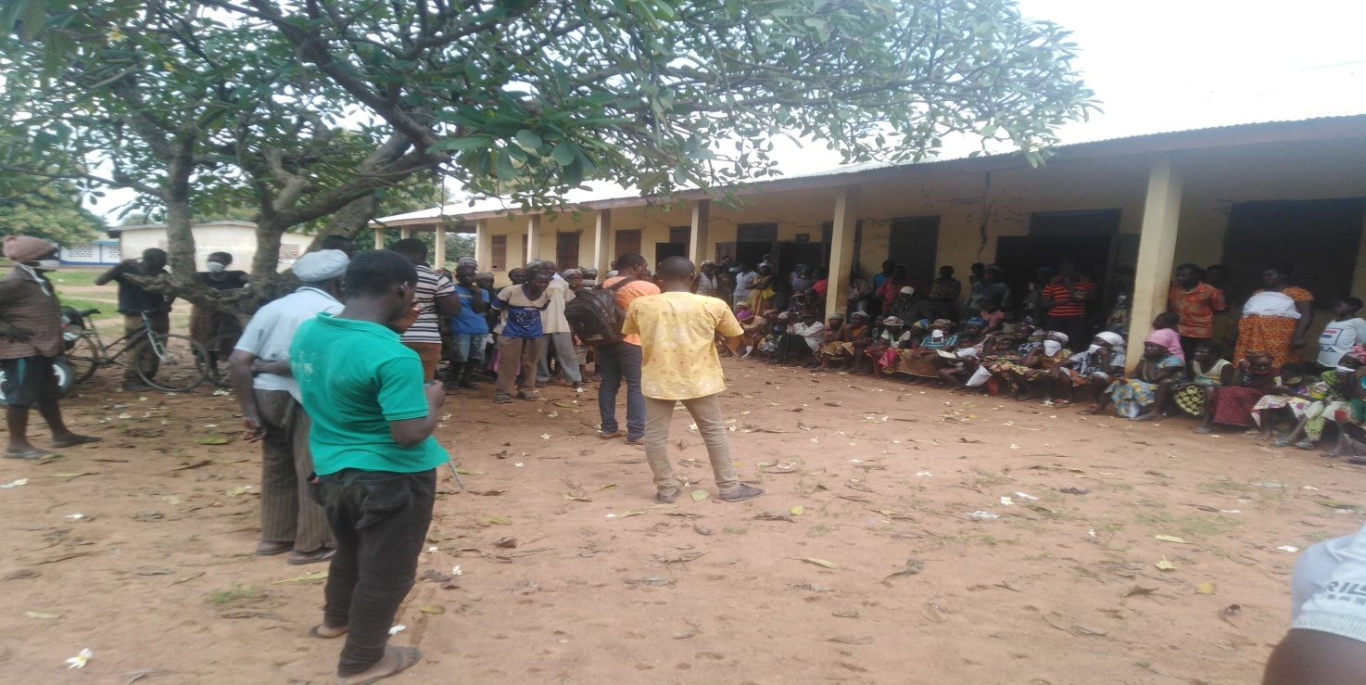

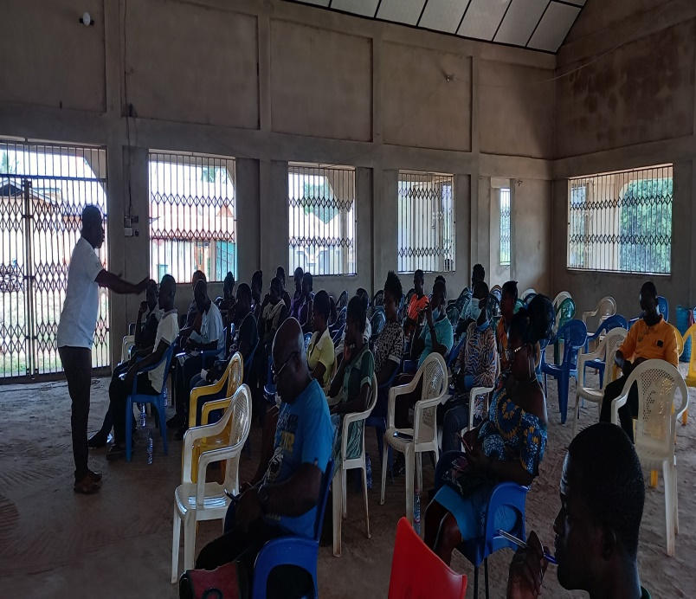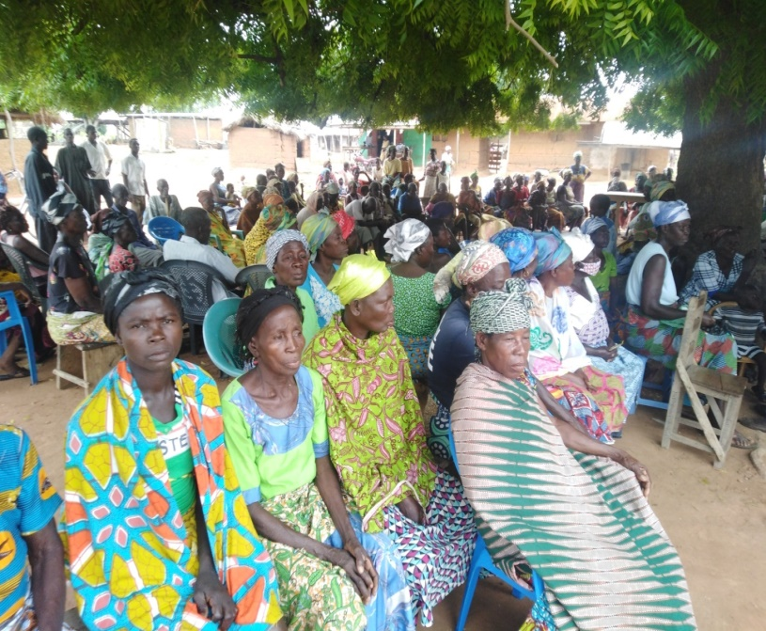

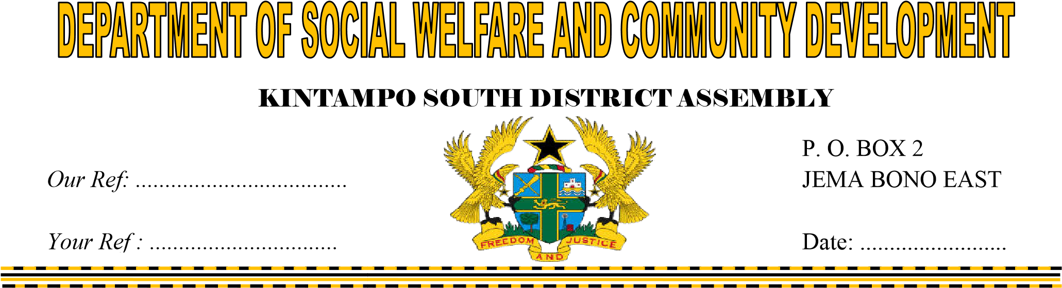

THE DISTRICT COORDINATING DIRECTOR

KINTAMPO SOUTH DISTRICT

JEMA

**SUBMISSION OF REPORTS ON CHILD PROTECTION ACTIVITIES FOR 2022**

I herewith submit first quarter report on child protection for 2022 for your study and necessary action.

Thank you

……………

Busi Donkor

HoD SWCD