**KINTAMPO SOUTH DISTRICT ASSEMBLY**

**DEPARTMENT OF SOCIAL COMMUNITY DEVELOPMENT**

**REPORTS ON SCHOOLS SENSITIZATION ON TEENAGE PREGNANCY**

**1. INTRODUCTION**

Teenage pregnancy has been an issue of great concern in most communities according to the district’s Ghana Education service statistics. This is affecting most girls of school age the opportunity to complete their basic education. As a result of this development, the Department of Social Development in collaboration with Ghana Education service girl Child education unit undertook sensitisation on the most affected communities and schools on causes and effects of Teenage pregnancy in six (6) communities namely Krabonso, Nante, Paninamisa, Chirehin, Sabule and Dumso Bethel. A total number of two hundred and ninety nine (299) people participated. Out of this, one hundred and forty six (146) were males whilst one hundred and fifty four were (154) females. The sensitization exercise was carried out from within the month of April and May, 2022.

**METHODOLOGY**

The team adopted facilitation and participatory approach through Community and school durbars with Role plays. These approaches were very relevant because it allowed citizens to have engagements and interactions with relevant Social and Child welfare service providers including Ghana Education service Girl child education unit to seek clarifications on relevant Child and family welfare related issues.

The activities were targeted at the general public. Specific target population includes Community leaders, In- School youth, parents and guidance, girls clubs and their coordinators.

The facilitation was conducted by Social Welfare Officers and Girl Child education coordinators.

**TARGET GROUP.**

The activity targeted at the following;

* Parents,
* Teacher,
* Traditional leaders
* Assemblymen,
* Students

**NUMBER OF PARTICIPANTS PRESENT PER THE COMMUNITIES**

|  |  |  |  |  |
| --- | --- | --- | --- | --- |
| **S/N** | **COMMUNITY** | **MALES** | **FEMALES** | **TOTAL** |
| 1 | KRABONS0 | 57 | 75 | 132 |
| 2 | NANTE | 59 | 70 | 129 |
| 3 | PANINAMISA | 58 | 75 | 133 |
| 4 | SABULE | 47 | 61 | 108 |
| 5 | DUMSO BETHEL | 52 | 63 | 115 |
| 6 | CHIREHIN | 54 | 78 | 132 |
|  | **TOTAL PARTICIPANTS** | **327** | **422** | **749** |

**OBJECTIVES OF THE SENSITISATION**

The sensitisation seeks to;

1. Educate parents and guidance on the negative effects of teenage pregnancy and its consequences on the future of the victim and the need for parents to monitor their girl child.
2. Educate parents on the importance of education and the need to monitor their pregnant girls in an unfortunate event and ensure their reintegration back to school after delivery.
3. Advise students to desist from pre-marital sex and immoral behaviours and concentrate on their education.

**HIGHLIGHTS KEY ISSUES DISCUSSED**

Issues discussed were centred on but limited to student truancy, the quest for money by school girls, parental neglect, child marriage, peer pressure, girls/ children engagement in night work and others which form part of the factors which mostly fuel teenage pregnancy.

Both parents and especially the students were sensitized to be watchful and guard against such acts. The facilitators emphasised that the effects of these could be detrimental and could retard the progress of the entire family and the girls especially. However, the parents and guardians were advised to ensure re-integration of their girls into school after delivery. Pregnant girls who are willing to sit in class to study with their pregnancy were encouraged to do without any fear. Students were advised to desist from stigmatization against their colleague who are pregnant or has delivered and are in school.

Related issue emerged was that; Two (2) school girls were found pregnant at Dumso. Effort was made to reach their parents to encourage them to support the girls during and after delivery to go back to school.

Below is the itinerary of when the community sensitization was done and officers involved.

|  |  |
| --- | --- |
| **DATE** | **COMMUNITIES VISITED** |
| 8/04/2022 | KRABONS0 |
| 15/04/2022 | NANTE |
| 29/04/2022 | PANINAMISA |
| 13/05/2022 | SABULE |
| 18/05/2022 | DUMSO BETHEL |
| 27/05/2022 | CHIREHIN |

**CONCLUSION**

The exercise was very successful as the maximum cooperation was gained from the participants the follow up questions and concerns signify the participants are willing to change and also the opinion leaders pledge to oversee all child related infractions and report those that they cannot intervene to reduce the incidence of teenage pregnancies.

REPORT PREPARED BY;

………………………………..

**Godwin Agyarko Gyasi**

**APPENDEXES**

SOME PICTURES FROM THE EXERCISE

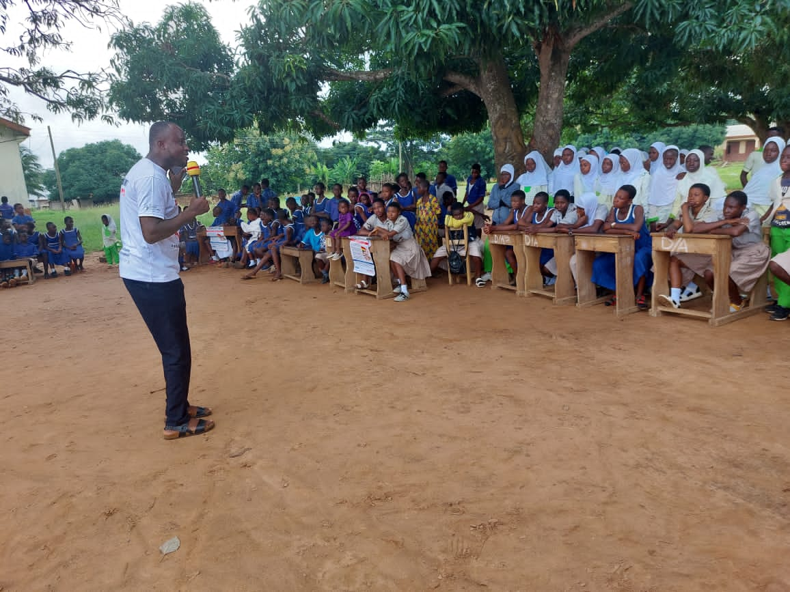

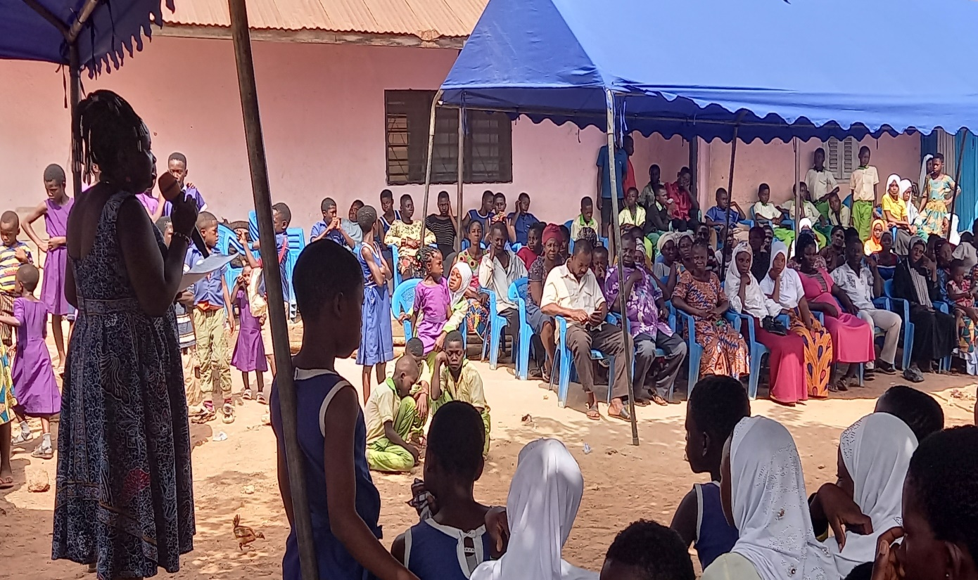

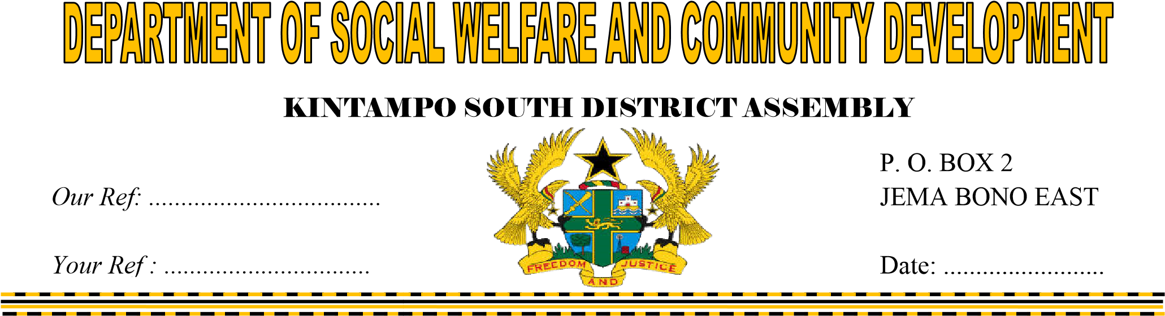

THE DISTRICT COORDINATING DIRECTOR

KINTAMPO SOUTH DISTRICT

JEMA

**SUBMISSION OF REPORTS ON GENDER BASE VIOLENCE ACTIVITIES CONDUCTED FOR 2022**

I herewith submit fourth quarter report on gender base violence 2022 for your study and necessary action.

Thank you

……………

Busi Donkor

HoD SWCD