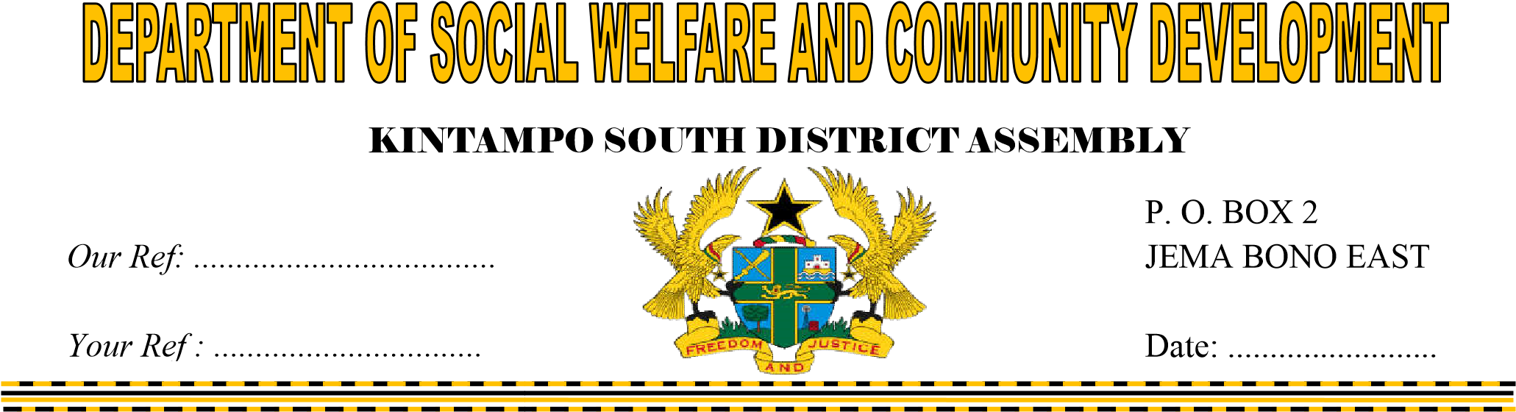

THE COORDINATING DIRECTOR

KINTAMPO SOUTH DISTRICT

JEMA

**SUBMISION OF NARRATIVE REPORT**

**FOLLOW UPS AND MONITORING OF PWDs AND YOUTH ENTERPRENUERSHIP FOR THE YEAR,2022**

I herewith submit fourth quarter report on the above activity for your perusal.

Thank you

………………..

Busi Donkor

HoD SWCD

**REPORT ON YOUTH ENTERPRENUERSHIP TRAINING (2022)**

**1. INTRODUCTION**

World Vision Ghana as part of its programs enrolled 138 youth into various forms of apprenticeship within 9 communities in the Kintampo south district. These young people were handed over to the Kintampo South Community Development unit for monitoring, supervision and support as part of the exist arrangements of World Vision. The Unit during the year under review conducted monitoring visits to these young people to assess their performance and provide some support and advice where necessary.

Generally, the intervention sought to provide school dropouts and teenage mothers with employable skills, also to reduce poverty and engaged them in decent employment and livelihood in the future.

**2. OBJECTIVE OF THE REPORT**

This report seeks to highlight the outcomes of the monitoring visit to the beneficiaries.

**3.1. MONITORING VISIT TO YOUTH CENTRES /COMMUNITIES**

During the year under review separate monitoring visits were paid to One Hundred and Thirty (138); Sixty-three (63) females and Seventy-five (75) males Youth who enrolled into livelihood and skills development interventions by World Vision – Kintampo south ADP. These forms of trades include carpentry, Mason, Welding, Glass fabrication, dressmaking and hairdressing.

The communities visited were Amoma, Anyima, Kintampo, Krabonso, Jema, Jema Nkwanta, Nante, Ntankoro and Apesika.

During the visits, it was revealed that all the needed tools, equipment’s and trade fees as well as uniforms were provided to the apprentice masters in various locations within the district. There were complaints received from their masters in some occasions about some of the beneficiaries who were not serious on their task and being truant. Again there some instances where some parents were spotted taking their wards/ children to farm at the expense of the skill training.

**Outcome of the monitoring**

Generally, the intervention created a platform and opportunity for the office to have direct engagement with the trainees and the trainers for deliberation and further coaching.

It also created access for on-site assessment of the youth in training, progress and track their performance on regular bases.

**4. CONCLUSION**

The department of social welfare and community development is grateful to its implementing partner for the support.

NUMBER OF TRAINEES PER TYPE OF TRADE

|  |  |  |  |  |
| --- | --- | --- | --- | --- |
| **#** | **Type of trade** | **No. of artisans** | | **TOTAL** |
| **Male** | **Female** |
| 1 | Dressmaking | 0 | 49 | 49 |
| 2 | Hairdressing | 0 | 14 | 14 |
| 3 | Electrical works | 16 | 0 | 16 |
| 4 | Welding | 19 | 0 | 19 |
| 5 | Carpentry | 10 | 0 | 10 |
| 6 | Mason | 20 | 0 | 20 |
| 7 | Glass fabrication | 10 | 0 | 10 |
|  | **Total** | **75** | **63** | **138** |

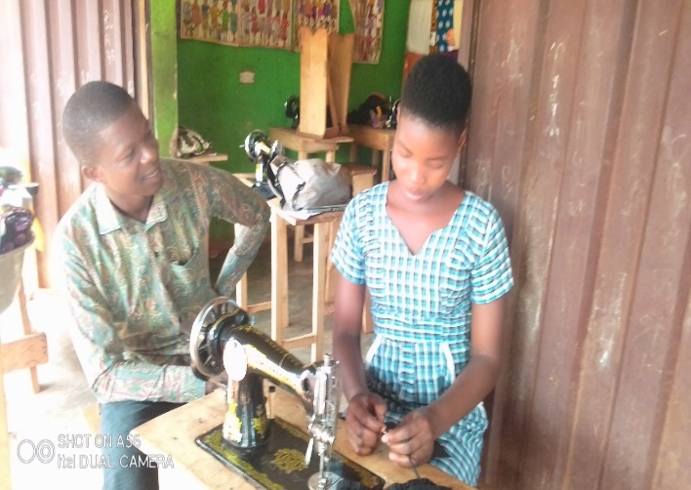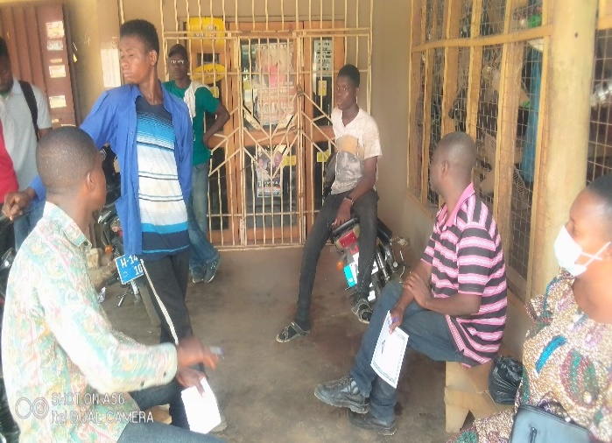**See below pictures taken during monitoring**

