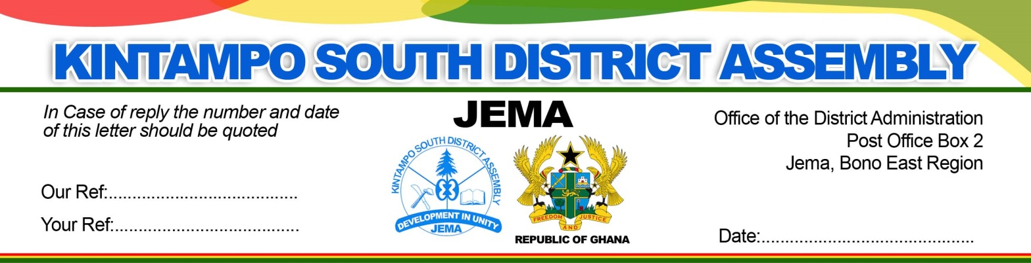

**03 /03 / 2021**

**REPORT ON TRAINING OF FOOD VENDORS ON FOOD HYGIENE PRACTICE AND FOOD NUTRITION.**

The above training was organized quarterly by the Environmental health officers led by the DEHO to ensure that all food preparation centers are clean to prevent any contamination that will cause diseases. The participants were 41 in number taking through environmental health and personal hygiene education to improve the hygienic preparation and handling of food. Also the participants were educated on balance nutritious food especially meals meant for school children to prevent malnutrition. The unit collaborated with the **EPA**, **FDA**, **MOFA**, **GES and SOCIAL WELFARE** during these training exercises**.**

Food is the most important commodity in human life and therefore need proper handling method that would prevent food borne diseases. It is therefore against this backdrop that the environmental Health Unit and other Departments are taking the initiatives to sensitize food, drinks and other consumable products vendors to improve the hygienic preparation of food meant for public consumption. The aim of this training exercise is to prevent diseases such as Typhoid, Hepatitis B, food poison and feaco-oral disease associated with their vending business.

The health officers stressed the importance of annual medical screening of food and vendors to know their health status and that of theirs assistant to safe guard the interest of their customers.

Table below indicate trainees invited

|  |  |  |  |  |  |
| --- | --- | --- | --- | --- | --- |
| **s/n** | **Categories of trainee’s invited** | **Male** | **Female** | | **Total** |
| 1 | School feeding contractors | 1 | 12 | | **13** |
| 2 | Food and drinks vendors | 3 | 14 | | **17** |
| 3 | Hospitality providers of food services | 3 | 2 | | **5** |
| 4 | Cool store/Butchers | 4 | 3 | | **7** |
| **11** | **31** | **41** | |

**INTRODUCTION**

Food safety is described as handling, preparation and storage of food in ways that prevent food borne illness. It compasses action aimed at ensuring that food is as safe as possible and would not pose any threat to the health of an individual when consumed, prevention of food contamination and promoting health living.

**RISK FACTORS TO FOOD SAFETY**

1. Using contaminated or spoilt ingredients.
2. Inappropriately cooked food.
3. Food prepared under unhygienic conditions.
4. Food prepared by unhygienic person.
5. Food not stored under proper condition.
6. Records and documentations.

**FOOD SAFETY MEASURES:**

1. Practices of food hygiene examples, Utensils and machinery.
2. Control of cross contamination.
3. Proper storage of kitchen waste.
4. Food vendors certified with health certificates.
5. Clean toilet and urinal facility.
6. Regular washing of clothing and training of nails.

**BENEFITS OF EATING SAFE AND NURITIOUS FOOD**

1. Proper growth and development.
2. Increase productivity of a country.
3. Reduces pressure on the available health resources.

Participants were very happy about such programs and always asked for more. Below depicts pictures taken during the training exercise.

**Thank you.**

**Datuah Bagolo Daniel**

**(Principal Environmental Health Officer)**

For: **District Environmental Health Officer.**

KINTAMPO SOUTH TRAINING

Training food vendors on food hygiene practice and balanced nutrition.

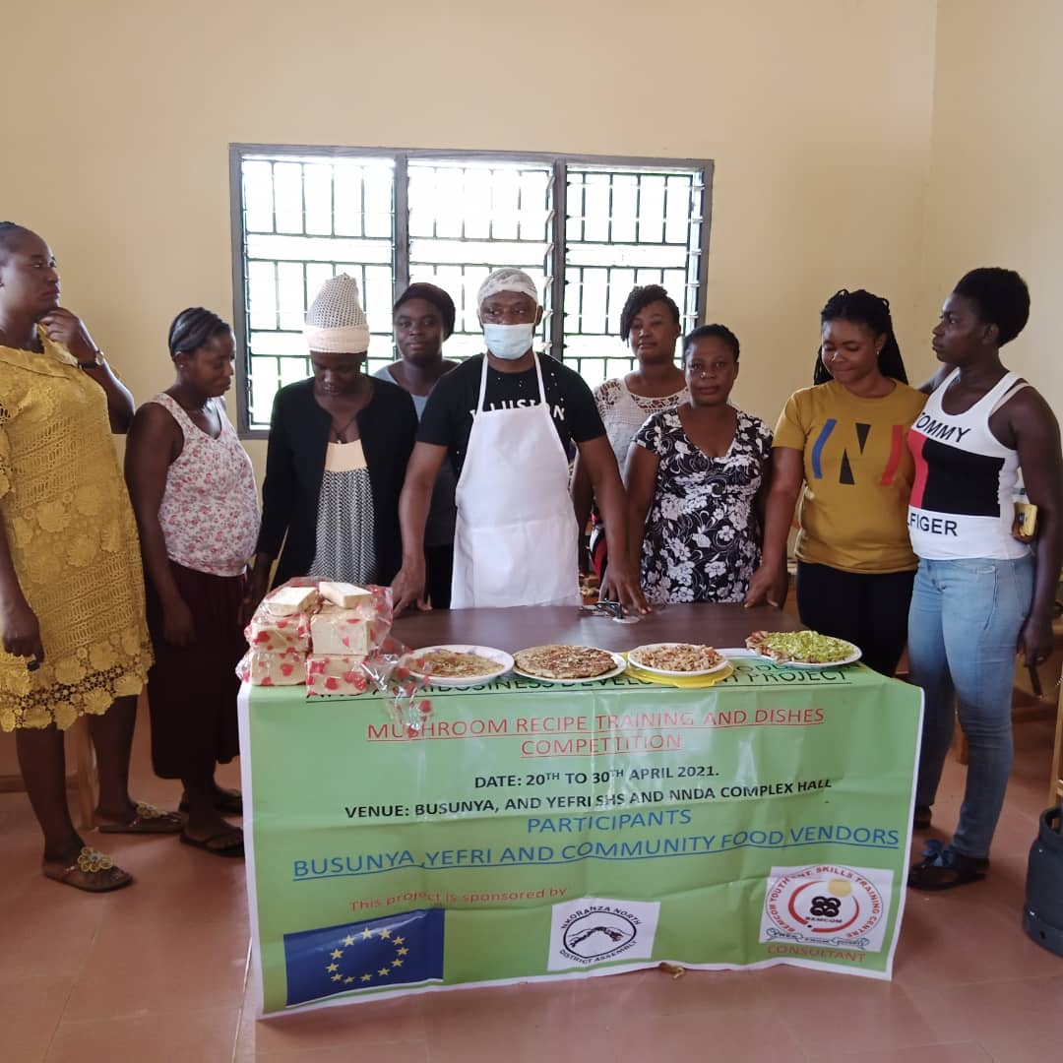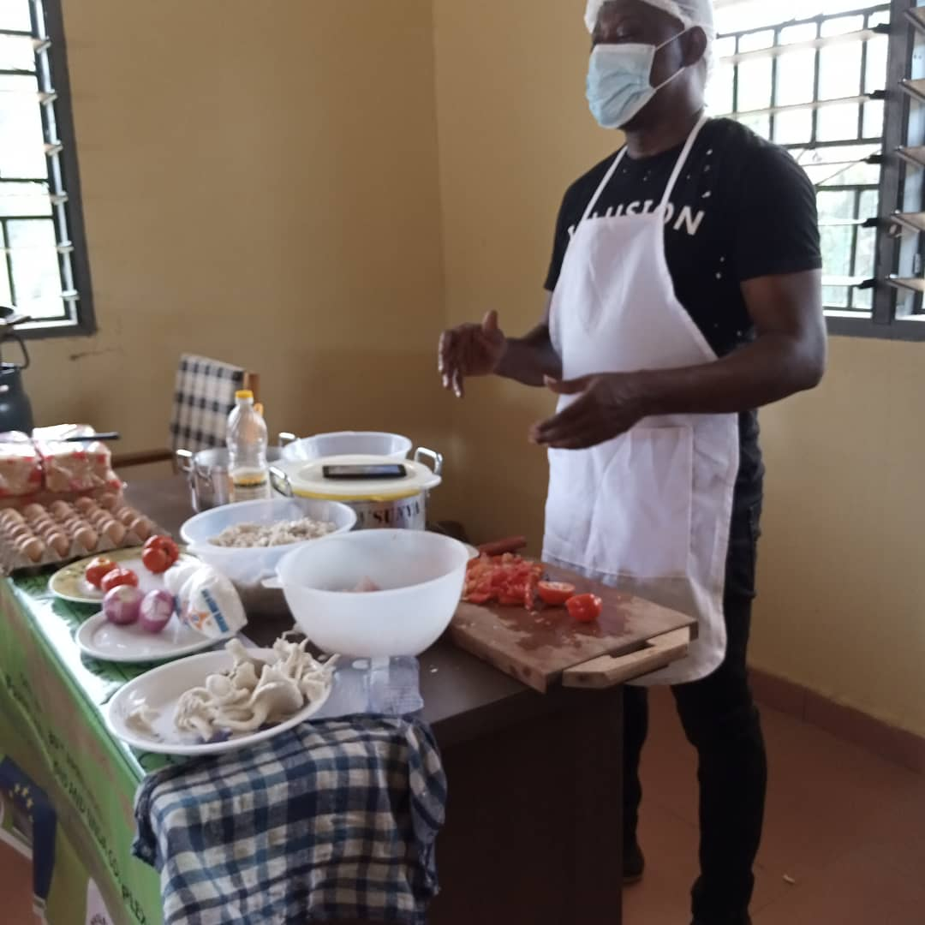

**List of Participants (Food Vendors and School Feeding Contractors)**

|  |  |  |  |
| --- | --- | --- | --- |
| No. | Name | Designation | Signature |
| 1 |  |  |  |
| 2 |  |  |  |
| 3 |  |  |  |
| 4 |  |  |  |
| 5 |  |  |  |
| 6 |  |  |  |
| 7 |  |  |  |
| 8 |  |  |  |
| 9 |  |  |  |
| 10 |  |  |  |
| 11 |  |  |  |
| 12 |  |  |  |
| 13 |  |  |  |
| 14 |  |  |  |
| 15 |  |  |  |
| 16 |  |  |  |
| 17 |  |  |  |
| 18 |  |  |  |
| 19 |  |  |  |
| 20 |  |  |  |
| 21 |  |  |  |
| 22 |  |  |  |
| 23 |  |  |  |
| 24 |  |  |  |
| 25 |  |  |  |
| 26 |  |  |  |
| 27 |  |  |  |
| 28 |  |  |  |
| 29 |  |  |  |
| 30 |  |  |  |
| 31 |  |  |  |
| 32 |  |  |  |
| 33 |  |  |  |
| 34 |  |  |  |
| 35 |  |  |  |
| 36 |  |  |  |
| 37 |  |  |  |
| 38 |  |  |  |
| 39 |  |  |  |
| 40 |  |  |  |
| 41 |  |  |  |
| 42 |  |  |  |
| 43 |  |  |  |
| 44 |  |  |  |
| 45 |  |  |  |
|  |  |  |  |