Table of Contents

1.0 EXECUTIVE SUMMARY. 2

2.0 ASSETS 2

2.1 HUMAN RESOURCE. 3

3.0 PROPOSITION FOR CAPACITY BUILDING FOR STAFF 3

CORE MANDATES. 4

5.0 FAMILY WELFARE/JUSTICE ADMINISTRATION. 4

5.1 SENSITISATION PROGRAMS UNDERTAKEN. 4

5.2 TRAINING PROGRAMS ORGANISED. 5

6.0 WORK WITH NGOs. 5

7.0 COMMUNITY CARE 5

7.1 PERSONS WITH DISABILITIES (PWDs) 6

7.2 LIVELIHOOD EMPOWERMENT AGAINST POVERTY (LEAP) 6

7.3 REGISTRATION OF INDIGENTS ON NHIS. 7

8.0 COLLABORATION WITH OTHER DEPARTMENTS. 8

8.1 GHANA HEALTH SERVICE. 8

8.1.1 NUTRITION FRIENDLY SCHOOL INITIATIVE PROGRAM. 9

8.2 ENVIRONMENTAL HEALTH UNIT. 10

9.0 CHALLLENGES 10

10.0 PROSPECTS 11

11.0 PLANNED ACTIVITIES FOR 2023 11

12.0 CONCLUSION 12

APPENDIXES. 13

# 1.0 EXECUTIVE SUMMARY.

The year 2022 began with high spirit and hope of delivering better results than before because of the roll out of the UNICEF ISS program which provide funding for child protection activities. Considering the successes achieved and the challenges we encountered in the previous year, the department is motivated to improve and achieve even better results.

Activities carried out in the year among other things included the LEAP payment, registration, vetting and approval of Persons with Disability (PWDs) for Disability Fund assess.

There has been an improvement in the reporting of cases involving Child Maintenance, child paternity, child protection, child custody, citizenry advice, referrals to family tribunal.

The successes chalked by the department so far are in areas of LEAP and PWD. A total amount of One Hundred and Forty-Three Thousand Six Hundred Fifty (GHC 143,650) was disbursed to Seventy-Four (74) PWDs who applied for support under Education, Health, Farming and Trading.

Six Cycles Leap payments were supervised in Fifty-Five (55) communities and Three Thousand and Ninety-eight (3,098) poor households have also benefited from LEAP cash grants. Amount involved was Four Hundred and Eighty-Four Thousand, and Seventy-eight Ghana Cedis, eighteen pesewas (GH₵ 484,078.18).

The major challenge of the Department is the lack of and or inadequate resources to embark on planned field activities.

# 2.0 ASSETS

The office is resourced with the following items;

|  |  |  |  |
| --- | --- | --- | --- |
| **S/N** | **ITEM** | **QUANTITY** | **CONDITION** |
| 1. | MOTORBIKE () | ONE (1) | OLD. |
| 2. | HP DESK TOP COMPUTER | ONE (1) | OLD |
| 3. | HP PRINTER | ONE (1) | BRAND NEW |
| 4. | HP LAPTOP (DUAL CORE) | ONE (1) | FAIRLY NEW |
| 5. | FILE CABINET | TWO (2) | OLD. |
| 6. | OFFICE CHAIR (SWIVEL) | ONE (1) | FAIRLY NEW |
| 7. | OFFICE CHAIRS (WOODEN) | TEN (10) | FAIRLY NEW |
| 8. | OFFICE TABLES | SIX (6) | FAIRLY NEW |

# 2.1 HUMAN RESOURCE.

The department is staffed with ten (10) permanent staff and three (3) National Service personnel. The staff are of varied levels in terms of educational backgrounds and qualification ranging from Masters’ degree to Diploma.

# 3.0 PROPOSITION FOR CAPACITY BUILDING FOR STAFF

Training programs in public management, Report writing, community needs assessment and alternative dispute resolution will be required to enhance staff’s efficiency and to gain job satisfaction.

# CORE MANDATES.

Per the Local Governance Act, 2016 Act 936, the Department of Social Development mandated to carry out the following activities in the MMDAs;

## 5.0 FAMILY WELFARE/JUSTICE ADMINISTRATION.

This aspect deals with situations of children and young persons who are caught by the law in one way or the other. The Department renders welfare or correctional services for offenders sentenced on probation and industrial institutions. That necessitates the representation of the Department in court to hear cases that involve juveniles and mediate and or render witnesses to back the claim of representatives of the juveniles.

During the year 2022, the Department sat on a number of cases in the office most of which were maintenance, child custody and child paternity in nature. Most of the cases revolved around teenage pregnancy, child neglect and irresponsible parenting.

The detailed analyses are captured in the table below:

|  |  |  |  |
| --- | --- | --- | --- |
| **ACTIVITY** | **NUMBER REGISTERED** | **SETTLED** | **PENDING** |
| CHILD MAINTENANCE | 9 | 9 | 0 |
| CHILD ABUSE | 0 | 0 | 0 |
| CHILD PATERNITY | 1 | 1 | 0 |
| CHILD CUSTODY | 0 | 0 | 0 |
| GENDER BASED VIOLENCE | 0 | 0 | 0 |
| GENERAL WELFARE | 11 | 11 | 0 |
| **TOTAL** | **21** | **21** | **0** |

## 5.1 SENSITISATION PROGRAMS UNDERTAKEN.

During the year 2022, the department did several sensitization programs in some communities in the district. These sensitization programs create avenues for the department to interact and educate the communities on social issues that will bring about social change. Some target outmoded cultural practices in the various communities, child abuse, child marriage, forced marriages, gender-based violence, teenage pregnancy, good parenting, etc.

Below is the summary of the number of participants present in the communities.

**SUMMARY OF BENEFICIARIES OF SENSITISATION PROGRAMS UNDERTAKEN IN 2022**.

|  |  |  |  |  |
| --- | --- | --- | --- | --- |
| **S/N** | **PROGRAM** | **PARTICIPANTS** | | |
| **MALES** | **FEMALES** | **TOTAL** |
| 1 | CHILD MARRIAGE | 45 | 64 | 109 |
| 2 | TEENAGE PREGNANCY | 36 | 86 | 122 |
| 3 | CHILD ABUSE | 106 | 117 | 223 |
|  | **CUMMULATIVE TOTAL** | **976** | **1,099** | **2,075** |

## 5.2 TRAINING PROGRAMS ORGANISED.

During the year under review, a number of training programs were organized in the various communities within the district to empower vulnerable groups in economic activities.

The table below gives the summaries;

|  |  |  |  |  |
| --- | --- | --- | --- | --- |
| **S/N** | **PROGRAM** | **PARTICIPANTS** | | |
| **M** | **F** | **TOTAL** |
| 1. | Entrepreneurial training for the youth and PWDs | 77 | 66 | 143 |
| 2. | Training of PWDs in liquid soap making | 15 | 106 | 121 |
| **3.** | **Total** | **92** | **172** | **264** |

## 6.0 WORK WITH NGOs.

There are two international NGO’s in the district; World Vision Ghana and Compassion International. Compassion International dwells on child protection and currently has child development centers in Ayorya, Nante and Krabonso.

## 7.0 COMMUNITY CARE

The Department also ensure the wellbeing of vulnerable groups: the aged, orphans, widows, children and Persons with Disabilities (PWDs). Among other things, it identifies and registers PWDs and vulnerable for social protection programs like PWD fund, Livelihood Empowerment Against Poverty (LEAP), NHIS registration payment exemptions for indigents etc. The Department also refers patients to community-based rehabilitation programs, hospital welfare services and gives them education on drug use. It administers the quarterly disbursement of the disability fund to PWDs as and when funds are available.

## 7.1 PERSONS WITH DISABILITIES (PWDs)

During the year, the Fund Management Committee (FMC) met and approved the request of One Hundred and Twenty Seven (127) PWDs across the district in various areas of request.

**SUMMARY OF THE BENEFICIARIES UNDER THE VARIOUS CATEGORIES.**

|  |  |  |  |  |
| --- | --- | --- | --- | --- |
| **S/N** | **CATEGORIES** | **BENEFICIARIES.** | | |
| **MALES** | **FEMALES** | **TOTAL** |
| 1 | HEALTH | 5 | 10 | **15** |
| 2 | EDUCATION | 7 | 5 | **12** |
| 3 | ECONOMIC SUPPORT | 41 | 59 | **100** |
| **4** | **TOTAL** | **53** | **74** | **127** |

Disbursement lists are attached to the table of appendixes.

## 7.2 LIVELIHOOD EMPOWERMENT AGAINST POVERTY (LEAP)

Currently, fifty-five (55) communities are on the LEAP program. There are also three thousand and ninety-eight **(3,098)** households benefiting from the program in the district.These vulnerable households get cash grants ranging from ghc 64 to ghc 108 bi-monthly depending on the size of the household.

During the year 2022, five (5) cycles of the LEAP payment were supervised by the department.

## 7.3 REGISTRATION OF INDIGENTS ON NHIS.

Throughout the year 2022, the department collaborated with National Health Insurance Authority (NHIA) in the district to renew the NHIS cards of indigents, consisting of Persons with Disabilities, the aged and LEAP beneficiary households in the district.

Below is the statistical breakdown of indigents registered;

|  |  |  |  |  |  |  |  |  |  |
| --- | --- | --- | --- | --- | --- | --- | --- | --- | --- |
| **S/N** | **COMMUNITY** | **NUMBER REGISTERED/RENEWED** | | | | | | | |
| **INDIGENT/SCH. FEEDING** | | | | | **LEAP** | | |
| **MALE** | | **FEM.** | | **TOTAL** | **MALE** | **FEMALE** | **TOTAL** |
| 1. | AGYINA | 53 | | 54 | | **97** |  |  |  |
| 2. | SABULE | 41 | | 56 | | **97** |  |  |  |
| 3. | SOORA | 173 | | 115 | | **288** |  |  |  |
| 4. | MANGOASE | 21 | | 29 | | **50** |  |  |  |
| 5. | BELIBOYE | 56 | | 94 | | **150** |  |  |  |
| 6. | DUMSO | 18 | | 29 | | **47** |  |  |  |
| 7. | AMOMA | 80 | | 106 | | **186** |  |  |  |
| 8. | GAZINYIN | 14 | | 16 | | **30** |  |  |  |
| 9. | PANINAMISA | 5 | 5 | | **10** | | 10 | 21 | **31** |
| 10. | NANTE | 199 | 200 | | **399** | | 8 | 7 | **15** |
| 11. | SUAMIRE | 78 | 78 | | **156** | |  |  |  |
| 12. | BAABU | 21 | 38 | | **59** | |  |  |  |
| 13. | ABUDWOM | 17 | 25 | | **42** | |  |  |  |
| 14. | KRABONSO | 114 | 111 | | **225** | |  |  |  |
| 15. | APESIKA | 538 | 656 | | **1,194** | |  |  |  |
| 16. | ANOKYEKROM | 46 | 38 | | **84** | |  |  |  |
| 17. | HINDO | 205 | 347 | | **552** | |  |  |  |
| 18. | BEPOSO | 30 | 40 | | **70** | | 0 | 1 | 1 |
| 19. | HYIRESO | 23 | 42 | | **65** | |  |  |  |
| 20. | YEREPIMSO | 26 | 30 | | **56** | |  |  |  |
| 21. | PUMPUATIFI | 12 | 59 | | **71** | |  |  |  |
| 22. | AGYEGYEMAKUNU | 89 | 268 | | **357** | |  |  |  |
| 23. | MANSIE | 665 | 196 | | **861** | |  |  |  |
| 24. | CHIREHIN | 15 | 17 | | **32** | | 0 | 1 | 1 |
| 25. | KOOFIEKROM | 67 | 11 | | **78** | |  |  |  |
| 26. | ANYIMA | 58 | 52 | | **110** | |  |  |  |
| 27. | PAMDU | 64 | 82 | | **146** | |  |  |  |
| 28. | KWABIA | 187 | 147 | | **334** | |  |  |  |
| 29. | YEMOAKROM | 56 | 72 | | **128** | |  |  |  |
| 30. | JERUSALEM | 18 | 11 | | **29** | |  |  |  |
| 31. | DUMANAFOUR | 135 | 165 | | **300** | |  |  |  |
| 32. | DUMSO | 112 | 120 | | **232** | |  |  |  |
| 33. | NANTE-ZONGO | 22 | 32 | | **54** | |  |  |  |
| 34. | AKRUMA | 6 | 9 | | **15** | |  |  |  |
| 35. | AYORYA | 75 | 99 | | **174** | |  |  |  |
| 36. | NANTE-ESI | 25 | 11 | | **36** | | 11 | 1 | 12 |
| 37. | KOKUMA | 147 | 21 | | **168** | | 3 | 0 | 3 |
| 38. | JEMA NKWANTA | 19 | 7 | | **26** | | 5 | 2 | 7 |
| 39. | KRUTAKYI | 95 | 107 | | **202** | |  |  |  |
| 40. | BREDI | 34 | 59 | | **93** | |  |  |  |
| 41. | WEILA | 26 | 36 | | **62** | |  |  |  |
| **42.** | **CUMM. TOTALS** | **3,685** | **3,680** | | **7,365** | | **37** | **33** | **70** |

# 8.0 COLLABORATION WITH OTHER DEPARTMENTS.

During the year under review, the department of Social Welfare and Community Development collaborated with other departments to implement some programs that are targeting the vulnerable and the girl child. Notable among the Departments are;

## 

## 8.1 GHANA HEALTH SERVICE.

we collaborated with Ghana Health Service to implement several Nutrition Intervention programs in the district during the year under review.

Below is the list of the programs and the respective beneficiaries;

|  |  |  |  |  |
| --- | --- | --- | --- | --- |
| **S/N** | **PROGRAM** | **PARTICIPANTS** | | |
| **M** | **F** | **TOTAL** |
| 1. | Girls Iron Folic Acid Supplementation for adolescent girls in and out of school. | - | 1,350 | 1,350 |
| 2. | Vitamin A supplementation for children under 5 | 255 | 309 | 564 |
| 3 | Promotion and sensitization of exclusive breastfeeding | - | 709 | 709 |
| 4. | Sensitization of mothers on timely introduction of complimentary foods starting from six (6) months. | - | 709 | 709 |
| 5. | Improved feeding practices for the 1st 1000 days project. | 250 | 459 | 709 |
| **6.** | **TOTALS** | **505** | **3,536** | **4,041** |

### 8.1.1 NUTRITION FRIENDLY SCHOOL INITIATIVE PROGRAM.

The department collaborated with GHS to implement this program in eight (8) schools within the district. The program is geared towards increasing the nutritional status of school pupils through ensuring students have access to safe healthy eating and nutritious foods, ensure provision of adequate WASH (Water, Sanitation and Hygiene) facilities in the schools, promoting healthy eating including consumption of fresh fruit and iron-rich foods through nutrition education, providing students with the opportunity to engage in daily physical activity and creating green environment in the schools. Making sure food vendors in various schools are educated to prepare healthy and nutrition foods and they must have health certificates with adequate space with table and chair at school canteens.

Below is the breakdown of the beneficiaries;

|  |  |  |  |  |
| --- | --- | --- | --- | --- |
| **S/N** | **SCHOOL** | **NUMBER OF PUPILS** | | |
| **MALES** | **FEMALES** | **TOTAL** |
| 1. | NANTE ZONGO D/A | 85 | 115 | **200** |
| 2. | NANTE PRESBY | 39 | 89 | **128** |
| 3. | AMPOMA D/A | 57 | 102 | **159** |
| 4. | JEMA NKWANTA D/A | 36 | 85 | **121** |
| 5. | BEPOSO D/A | 54 | 96 | **150** |
| 6. | PANINAMISA MARE E. SCHOOL | 75 | 108 | **183** |
| 7. | NTANKRO D/A | 103 | 156 | **259** |
| 8. | PAMDU D/A | 51 | 96 | **147** |
| **9.** | **TOTAL** | **500** | **847** | **1,347** |

## 8.2 ENVIRONMENTAL HEALTH UNIT.

During the year under review, the District Environmental Health Unit and the School Feeding desk Officer organize an orientation and screening program for some food vendors and school feeding caterers in February. Below is the summary of statistics of the participants;

|  |  |  |  |  |
| --- | --- | --- | --- | --- |
| **S/N** | **COMMUNITY** | **PARTICIPANTS** | | |
| **MALES** | **FEMALES** | **TOTAL** |
| 1. | MANSIE | 6 | 19 | **25** |
| 2. | AYORYA | 11 | 45 | **56** |
| 3. | JEMA NKWANTA | 2 | 21 | **23** |
| 4. | WEILA | 4 | 39 | **43** |
| 5. | SABULE | 11 | 160 | **171** |
| 6. | NANTE | 3 | 65 | **68** |
| 7. | AMOMA | 5 | 88 | **93** |
| 8. | AGYINA | 2 | 41 | **43** |
| 9. | APAASO | 0 | 31 | **31** |
| 10. | CHIREHI | 4 | 35 | **39** |
| 11. | BREDI | 3 | 16 | **19** |
| 12. | JEMA | 23 | 82 | **105** |
| **13.** | **CUMM. TOTALS.** | **74** | **642** | **716** |

After the screening exercise, nineteen (19) were tested positive of Hepatitis B and twenty-four (24) were also tested positive of typhoid. Six hundred and eleven (611) were cleared and certified.

# 9.0 CHALLLENGES

The Department is faced with several major challenges which stifle workflow and does not allow for efficiency and job satisfaction. These are listed below:

* The delay in release of funds or in most cases, lack of funds to carry out planned activities.
* Unavailability of basic logistic like motorbikes for field work and stationery for office work.
* Unavailability of a shelter home for children in need of care.
* Lack of office materials/logistics to carry out official duties.
* Poor road networks and inaccessibility of some communities during the raining season.

# 10.0 PROSPECTS

The Department is ripe with varied potentials needed for effective social and community development work. These are:

* The ability to use community development approach, process and intervention including training and education, participation, empowerment, advocacy, learning, seminar, workshop and forum to bring about improvement in quality of life of individuals, families, groups and communities.
* The ability to carry out community assessment, identify problems or needs, formulate plans, translate plans into practical development projects and mobilize required human resources for implementation, monitoring, evaluation and re-planning.
* Staff skilled in computing, research, data gathering, analysis and interpretation.
* Staff ability to communicate effectively to community folks in their local dialect.
* Ready office to accommodate office and research materials and all other logistics required to carry out departmental activities effectively.

# 11.0 PLANNED ACTIVITIES FOR 2023

The Department looks forward to carry out the following activities in the next quarter:

* Community care; which will involve LEAP payments, PWD album creation and Indigents NHIA registration
* Capacity building workshop for PWDs on business entry and start up techniques.
* Justice administration; which will involve guidance and counseling, maintenance, child paternity and child custody cases.
* Generate a database of day Care Centers; which will involve advocacy for the registration of Day Care Centers in the district.
* Extension services; which will involve the Department collaborating with other Departments, Agencies and Units to carry out specific programs.

# 12.0 CONCLUSION

The Department cannot take much pride in current achievements since we are very much convinced that we can do far better with the needed assistance. It is our hope that in the next year, the department will be given the needed assistance to help ensure the efficient implementation of field programs and also do more sensitization on family welfare to see an appreciable level of cases been reported to the office for settlement.

**COMPILED BY:**

**…………………..**

**PHILLIP BEDIAKO**

**SDO.**

**APPENDIX.**

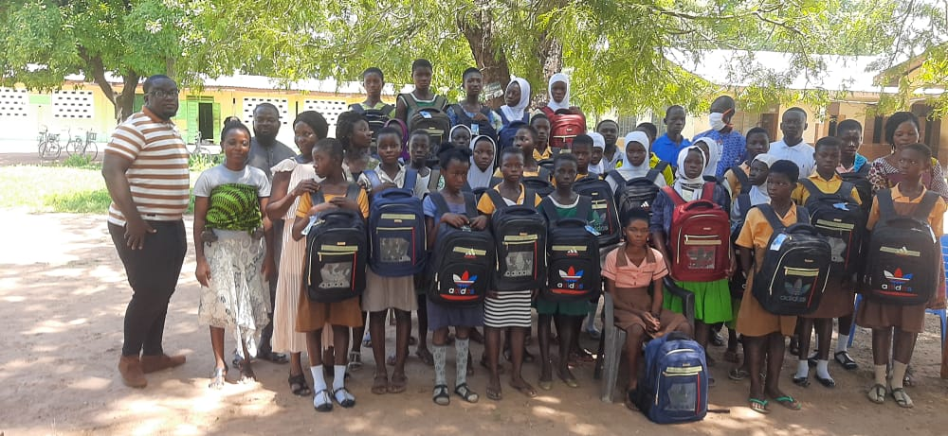

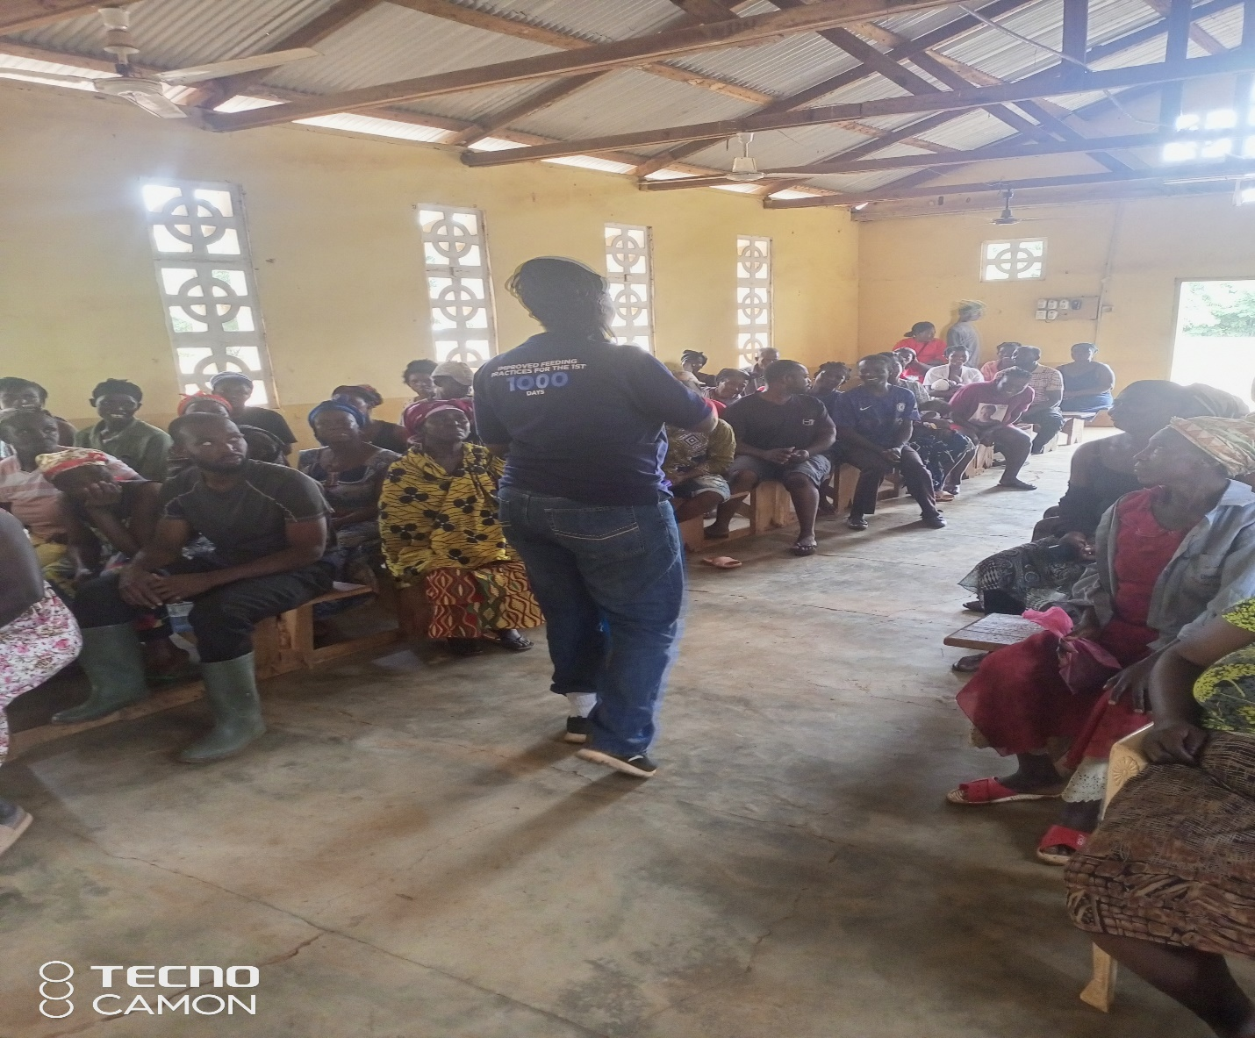

**KINTAMPO SOUTH DISTRICT ASSEMBLY.**

**DEPARTMENT OF SOCIAL WELFARE & COMMUNITY DEVELOPMENT.**

**ANNUAL PROGRESS REPORT**

**--DECEMBER 2022--**