**KINTAMPO SOUTH DISTRICT ASSEMBLY**

**DEPARTMENT OF SOCIAL DEVELOPMENT**

**REPORT ON VOCATIONAL TRAINING FOR PERSONS WITH DISABILITIES (PWDs) ON LIQUID SOAP PASTRIES MAKING**

**INTRODUCTION.**

Empowering PWDs to earn a decent living is one of the main focus of the Department of Social Development. It is for this singular reason that 3% of the statutory common fund are dedicated to PWDs. In the Kintampo South District, a lot of efforts are channelled into ensuring the economic liberation of the PWDs within our catchment area; ranging from sensitisation on the rights of these PWDs, ensuring their periodic meetings to discuss issues that concern them, supporting them financially to access education and health and also empowering them economically on vocational skills acquisition.

In reference to the previous meeting held, on the 11th April, 2021 at the social Welfare Office the Fund Committee agreed that a capacity a vocational training be organized for One hundred twenty one (121) persons Living with Disability in other to impart their livelihood positively and they also agreed that, all the one hundred and twenty one (121) PWDs who will be trained on the vocational skills be considered and served with a start up to commenced their own businesses.

Before the training started, Mr. Gyamena Samuel, the District Coordinating Director had a special talk to the selected one hundred and twenty one (121) PWDs to take the training since it may go a long way to help them and their family in future. He promised them that, he will make sure they are being considered and serve in the upcoming PWD common fund release.

The training was done in two days, which started 13th - 14th July, 2022. The training was done in two sessions as well and the divisions as fellows;

* Pastries, Meat pie, cookies, spring roll etc.
* Liquid soap and parazone making

**TARGET GROUP**

The training targeted PWDs, particularly women in poor communities who are interested in a vocation in liquid soap making

**PURPOSE OF THE TRAINING.**

The training was intended to:

1. Enhance the knowledge of the participants on liquid soap making.
2. Assist the beneficiaries to acquire the needed practical skills in making liquid soap and shower gel.
3. Enable the beneficiaries make a living through the sales of liquid soap and training of people on same.
4. Reduce the over dependence of those beneficiaries on family members and government institutions by offering them a decent living through trade in liquid soap.

**DAY 1**

The day one activities started with the Liquid soap and Parazone making. The facilitators for both Liquid soap and parazone making were Mad. Akosua Fabea and Mad. Adwoa Boahenmaa.

Mad. Akosua Fabea started with the Liquid soap making and before she started, all the necessary items for both liquid soap and the parazone making were shown to all the 121 beneficiaries.

Items for Liquid Soap Making includes;

* Salt
* Base
* Thickna powder
* Preserver powder
* Perfume
* Colour

And the items for the Parazone making also includes;

* Soda ash
* Powder
* Colour
* Adwayeawaye

She made sure all the participants were available before she started the process and she asked questions intermittently to make sure the participants understood the process.

The day ended with miles on the participants faces as they were all able to make samples of the products on their own after the training.

**DAY 2**

We started with Pastries, which was last on the capacity building for the selected one hundred and Twenty one (121) persons living with disabilities on day two. The facilitator for training was Mad. Bawa Emilia.

Madam Bawa trained the beneficiaries on four (4) pastries work which includes; Spring roll, Cookies, Meat Pie, and Chips. The materials for the above pastries includes;

Flour, margarine, cooking oil, nut meg, flavour, sugar, salt, garlic, onion, baking powder, food colour, cutter, serving spoon, oven, wooding spoon, frying pan, among others .

Just as the day ended, the participants were able to make samples of all the pastries and they were very excited the knowledge and skills they have acquired.

**RECOMMENDATION**

They recommended such activates be conducted periodically to enable others who could not participate also acquire such a wonderful skills.

Mr. Kwabena Nsoah from Ampoma thanked the committee for organising such training to equip them and they promised to make use of the3 skills they have acquired.

**CONCLUSION**

Isaac Opoku Aduboffour who is the Social Welfare Officer led the closure of the training sessions.

**NUMBER OF PARTICIPANTS PRESENT PER THE COMMUNITIES**

|  |  |  |  |  |
| --- | --- | --- | --- | --- |
| **S/N** | **COMMUNITY** | **MALES** | **FEMALES** | **TOTAL** |
| 1 | JEMA | 3 | 9 | 12 |
| 2 | JEMA NKWANTA | 4 | 14 | 18 |
| 3 | KRBONSO | 2 | 9 | 11 |
| 4 | NANTE | 3 | 10 | 13 |
| 5 | AMOMA | 3 | 13 | 16 |
| 6 | AGYINA | 3 | 15 | 18 |
| 7 | AMPOMA | 2 | 13 | 15 |
| 8 | SUNSUMLINE | 4 | 14 | 18 |
|  | **Total** | **24** | **97** | **121** |

**APPENDIXES**

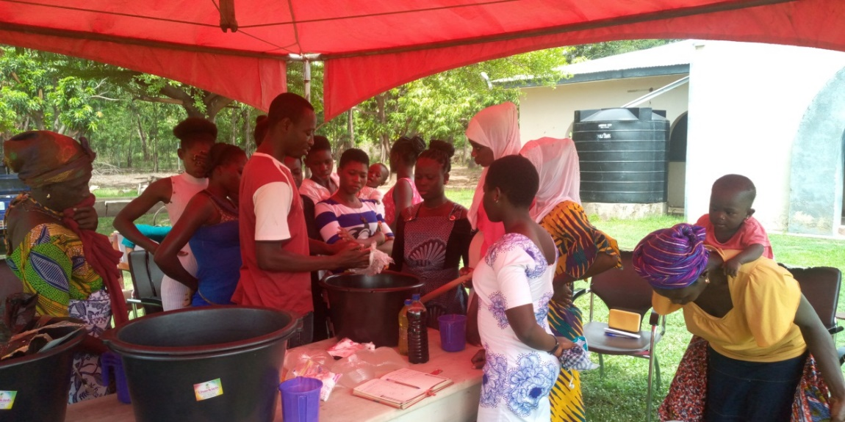

DEMONSTRATION ON SHOWER GEL AND LIQUID SOAP PRODUCTION

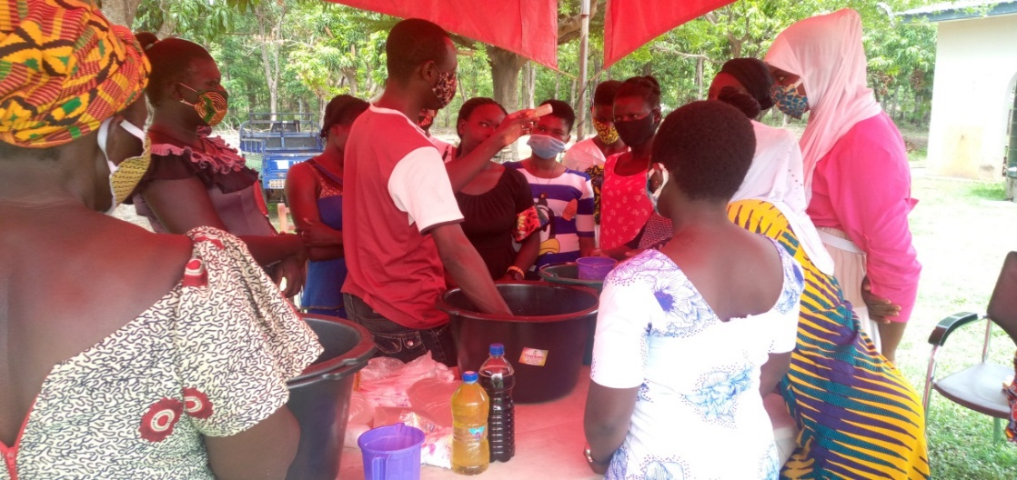

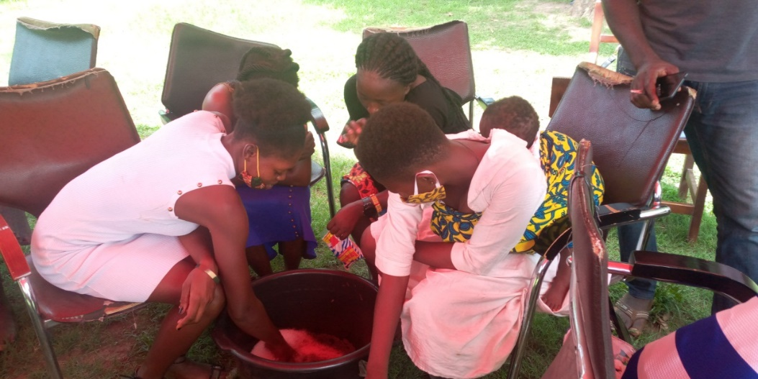

LIQUID SOAP AND SHOWER GEL PRODUCTION PRACTICALS